**Classification Configuration Manager**

Query Mode

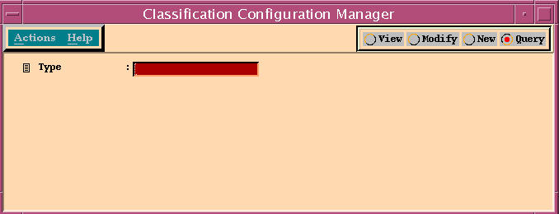

Type ListBox

exec CDB..CodeGet @Type = 'ClassificationClasses'

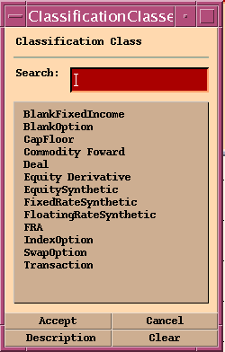

**Schema List Box**

**exec CDB..ClassificationSchemaByClass @Class = 'BlankFixedIncome'**

View After Selecting Type and Schema

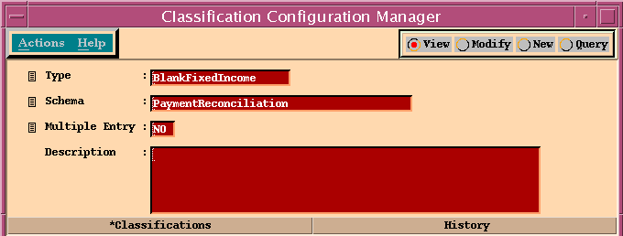

Classifications Panel

exec CDB..GetClassificationByKey @Class = 'BlankFixedIncome', @SchemaName = 'PaymentReconciliation'

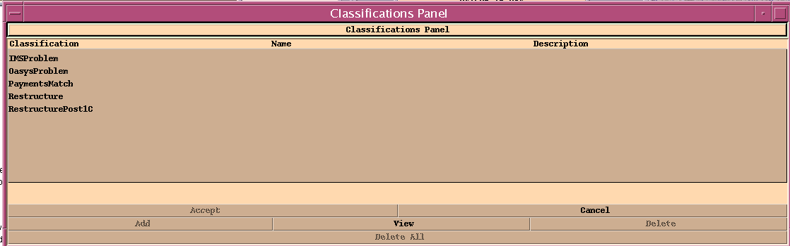

History Panel

exec DB..HistoryByKeyAndDateRange @Class="Classification",@ClassKey="BlankFixedIncome|PaymentReconciliation",@From="Nov 01 2016 06:29:48:000 AM",@To=NULL

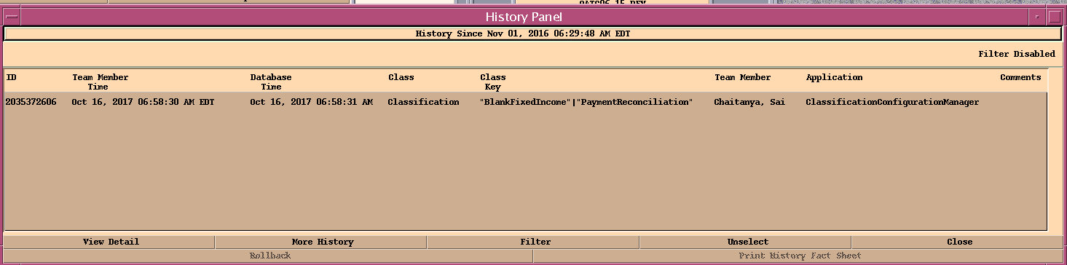

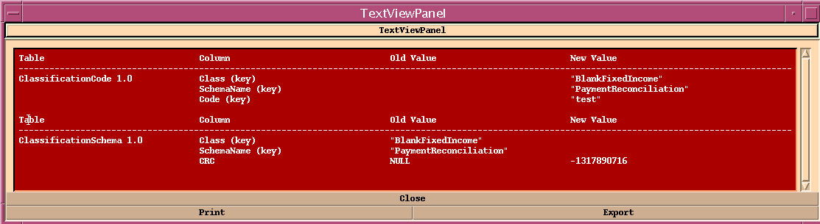\

New Mode

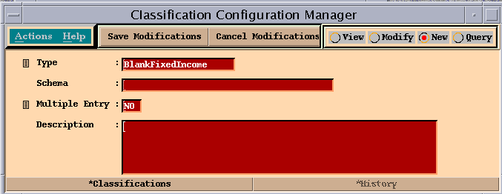

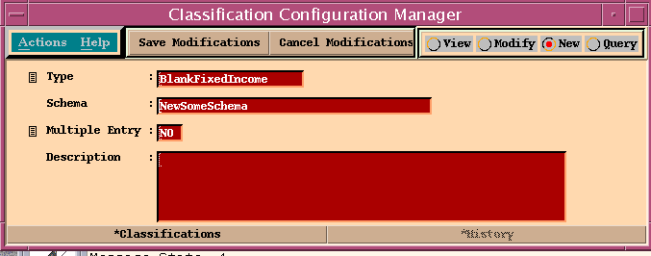

After Saving

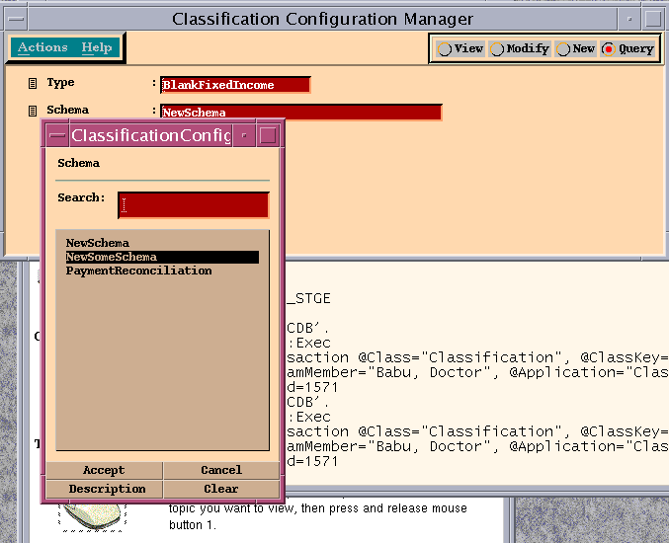

Adding New Classification from Classification Panel

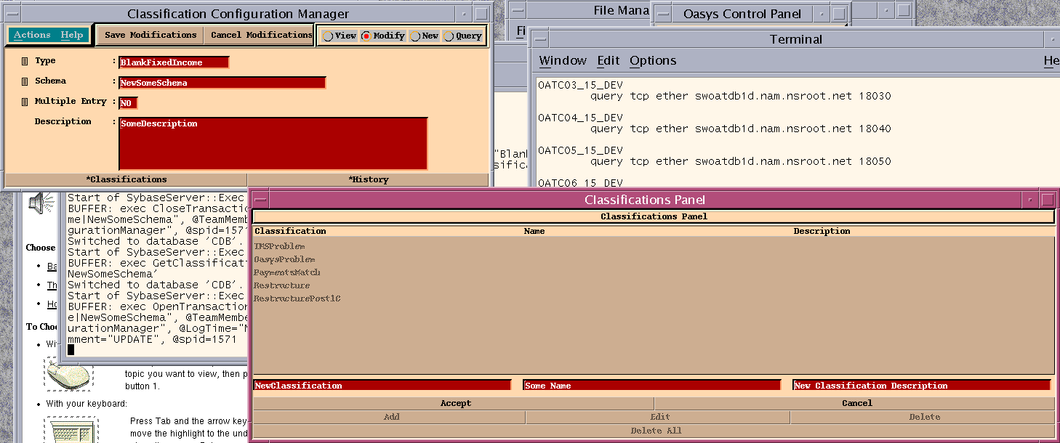

After Saving

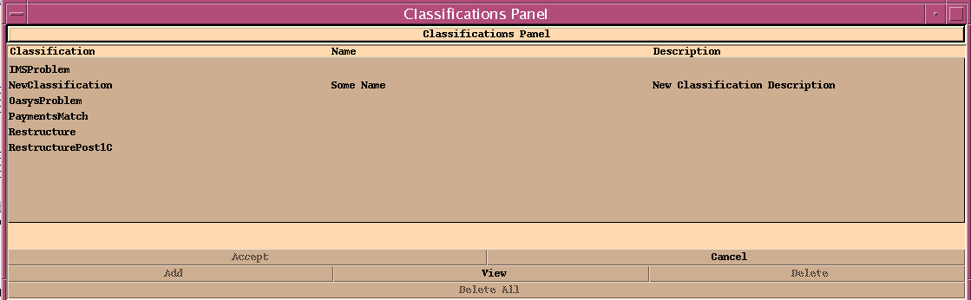

exec ClassificationSchemaUpdate @Class = "BlankFixedIncome", @SchemaName = "NewSomeSchema",@CRC = 2111810508

exec ClassificationCodeInsert @Class = "BlankFixedIncome", @SchemaName = "NewSomeSchema", @Code = "NewClassification",@LongName = "Some Name",@Description = "New Classification Description"